**ULTIMATE BUCKET LIST FOR UNITED KINGDOM**

The United Kingdom, also known as the United Kingdom of Great Britain and Northern Ireland, lying off the north-western coast of the European mainland, is one of the most admired nations in the world. As the country is amongst one of the first industrialized countries, the place possesses its unique significant impact on every sector like economy, politics, science, culture, sports, and so on. Millions of people from across the globe come to visit the United Kingdom, and love to explore the beauty of the nation. Giving books and movies like Harry Potter to a different style of music, the United Kingdom has always been an exemplar for other countries in terms of management, development, and growth in every sector.

The United Kingdom has 30 UNESCO world heritage sites, 15 national parks, phenomenal coastlines, quaint villages, stunning gardens, iconic landmarks, eclectic architecture, cathedrals and churches, and so on. Apart from these, it has its own unique style of events and functions and music legends. Not but the least, Wimbledon, and British Football is very well known to all of us. So, let's start from the tourist places one should visit in the United Kingdom.

1. **Westminster Abbey:** Westminster Abbey, a 700-year-old structure, is one of the most famous churches and picturesque sightseeing spots in London. This traditional place is known for the coronation and burial of British Monarchs. The church has burials of Stephen Hawking, Isaac Newton, Queen of Scots, and many other famous personalities. Mor1e than 3,300 people have been buried in Westminster Abbey. The church has majestic detailed interior carvings and tapestries.

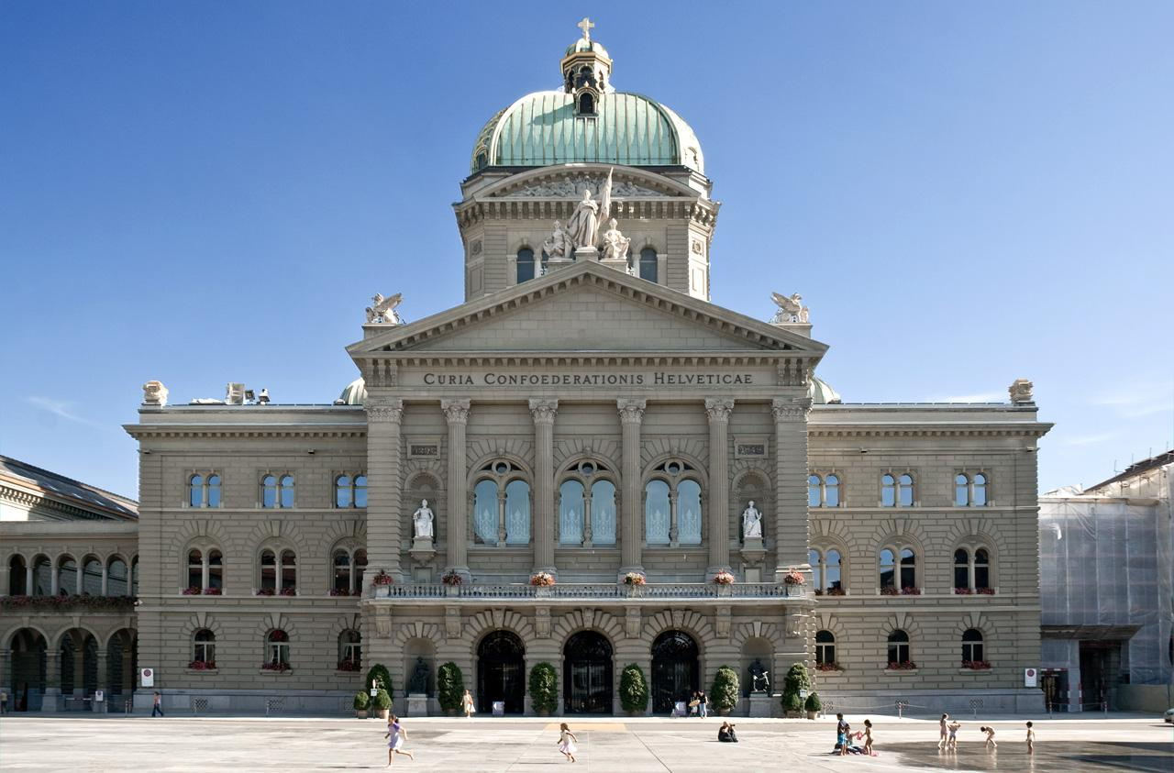

1. **The London Eye:** London Eye is Europe’s tallest Ferris wheel which is situated on the South bank of the River Thames in London. More than 4 million tourists visit this place every year. The wheel rotates about 3,500 km every year. It takes half an hour to travel the full length of the wheel which allows tourists a breathtaking view of the capital.

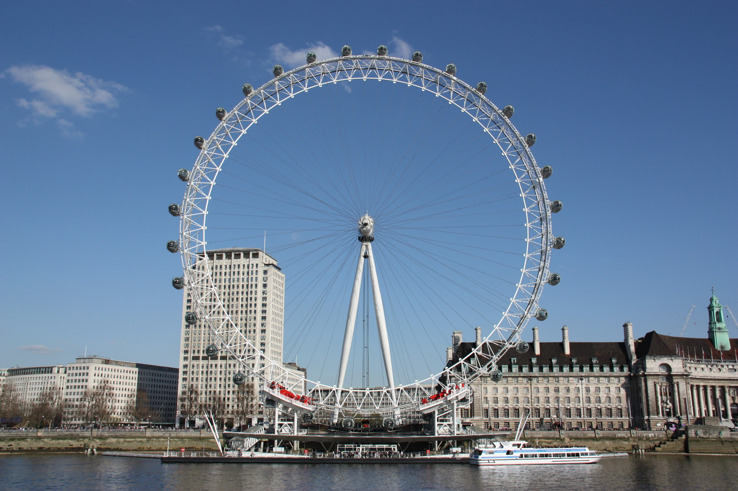

1. **Elizabeth Tower:** Elizabeth Tower which contains Big Ben is one of the iconic structures in the United Kingdom. It was known as the Clock Tower which was renamed as Elizabeth Tower in 2012. The Big Ben stands at the north end of the Palace of Westminster in London. People can take a tour of this place on Saturdays and during Parliamentary recesses. If you want to know about how British politics came to be today, you should visit Elizabeth Tower for sure.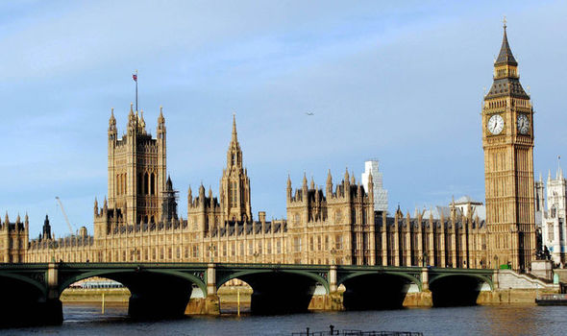
2. **St. Paul’s Cathedral:** The iconic cathedral is located on Ludgate Hill at the highest point of the city of London and is in the list of Grade I heritage destinations. It was founded in AD 604 and is dedicated to Paul the Apostle. If you want to climb the dome of the cathedral, you can visit the marvelous building on Saturday. The St. Paul’s Cathedral has the burial of Alexander Fleming, Henry Moore, Sir Joshua Reynolds, and many more renowned personalities. Apart from the burials, this place is also used by major celebrities for marriages.

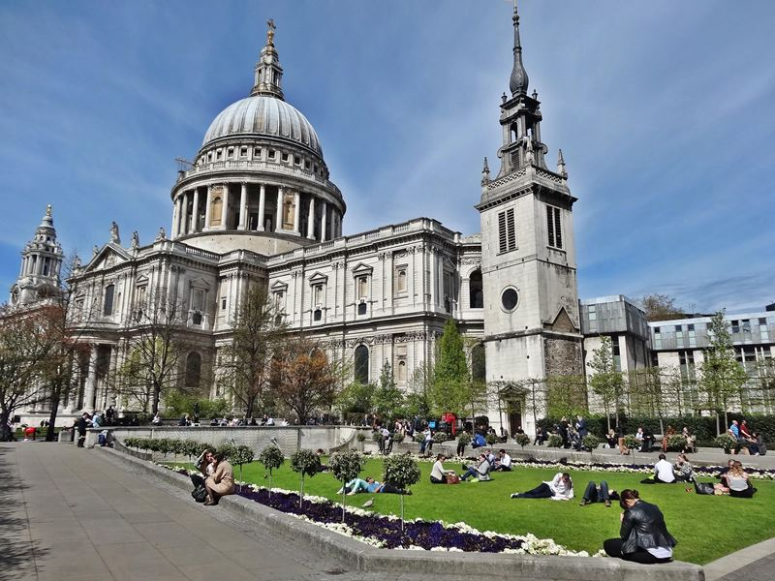

1. **Greenwich Observatory:** Greenwich Observatory, also known as “East meets West”, is the place where GMT has been calculated for centuries. It is located on a hill in Greenwich Park, overlooking the river Thames. If you want to stand on the Prime Meridian of the world and want to know how time was standardized in the UK, you must visit this place once. In this place, a person can stand with one foot in the Western Hemisphere and one in the Eastern Hemisphere.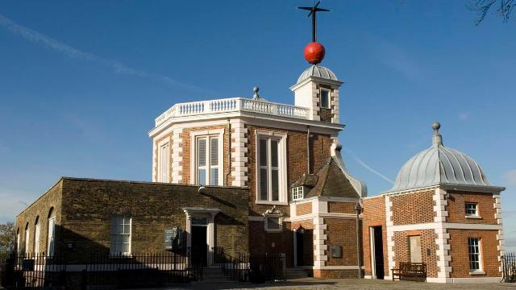
2. **Tower of London:** The Tower of London is a historic castle and located on the north bank of the River Thames. It was built by William the Conqueror. The Tower of London is home to the priceless Crown Jewels, the prison cell of Sir Walter Raleigh, also known as Bloody Tower, and the Chapel of St. John and the Royal Armories. Apart from this, it has served as the Royal Palace, the Royal mint, armory.

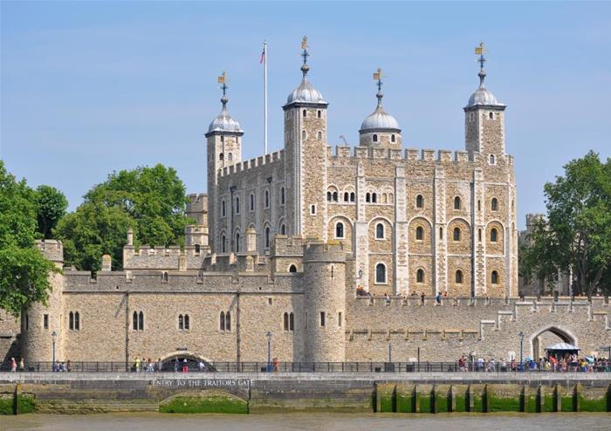

1. **Stonehenge:** The Stonehenge is one of the most popular historical monuments and located in Wiltshire, England. It has a ring of standing stones which are embedded into a landscape. The stone circle is over 4500 years old. The Stonehenge was added to UNESCO’s list of heritage sites in 1986.

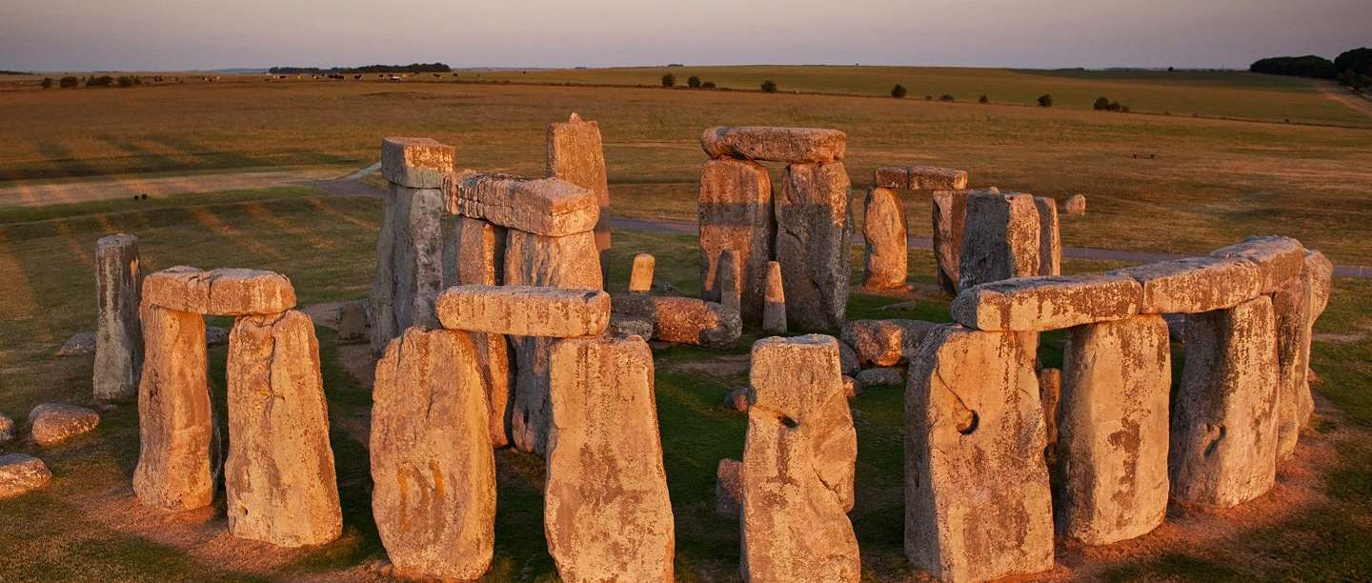

1. **Blenheim Palace, Oxfordshire:** This monumental country palace was built in the early eighteenth century and was the birthplace of the first Duke’s famous descendant, Winston Churchill.

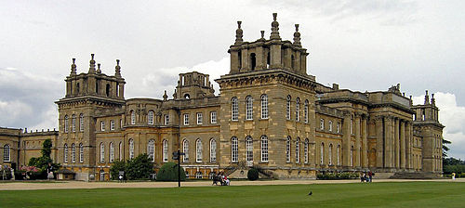

1. **Buckingham Palace:** The Buckingham Palace is the administrative headquarters of the monarch of the United Kingdom, has been official London residence since 1837. Buckingham Palace is located in the city of Westminster and has more than 350 working clocks and watches.

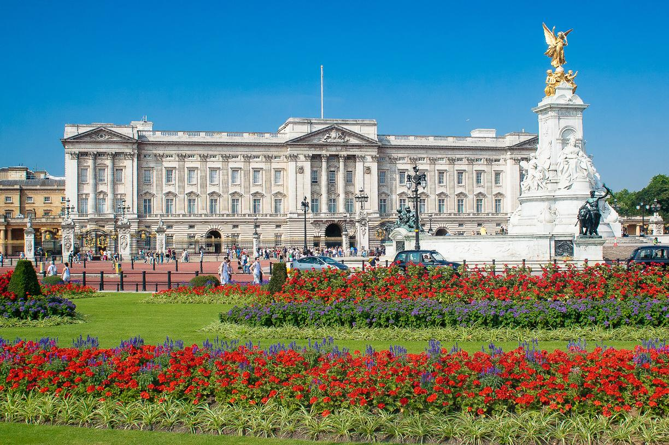

1. **Chester Zoo:** The Chester Zoo, formed in 1934, is the largest Orangutan exhibit in Europe. It was founded by George Mottershead. The zoo is home for more than 21,000 animals. Spread over 110 acres, the zoo has the world’s most endangered species.

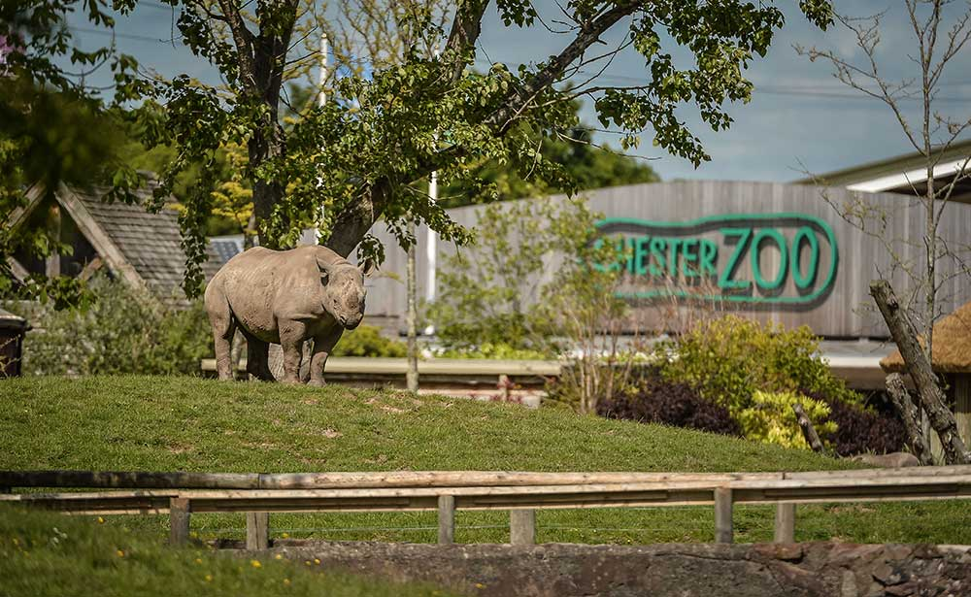

Apart from the above places, there are many more places a tourist can visit places like Isle of Skye in Scotland, Jurassic Coast in Britain, Arthur’s Seat in Edinburgh, White Sand Beaches of the Hebrides, British Museum, Brighton Pavilion, County Antrim Coastal road, Thames Path, Giant’s Causeway, Ben Hope, High Cup in the North Pennies, Hadrian’s Wall, and so on.

Also, there are many more things a tourist can include in his/her bucket-list before visiting the United Kingdom. One of the few options are listed below:

1. Go and watch Wimbledon
2. Spend an afternoon and have tea at the Ritz
3. Explore the Lake District
4. See a London West End Show
5. Explore the Shetlands Islands
6. Attend Notting Hill Carnival
7. Attend the Glastonbury Festival
8. Explore the countryside by steam train
9. Take a boat ride on Lake Windermere
10. Attend six nations rugby match
11. Go and visit Windsor Castle
12. Explore Sherwood Castle
13. Explore Cheddar Gorge